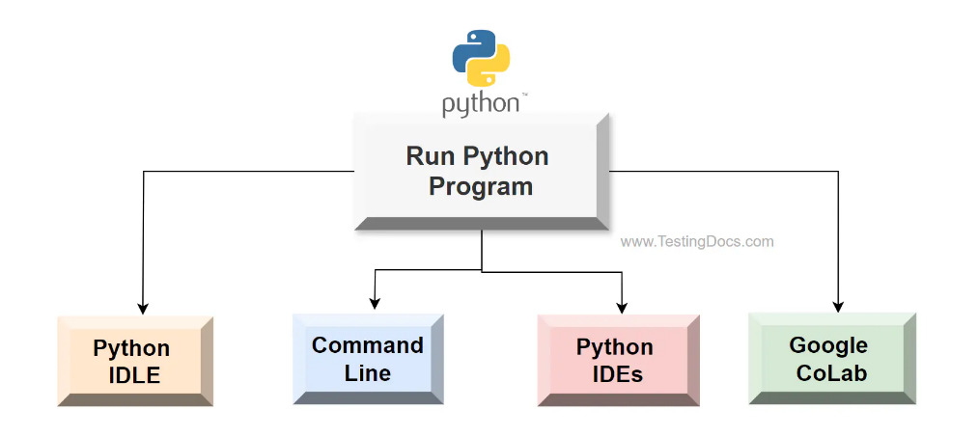

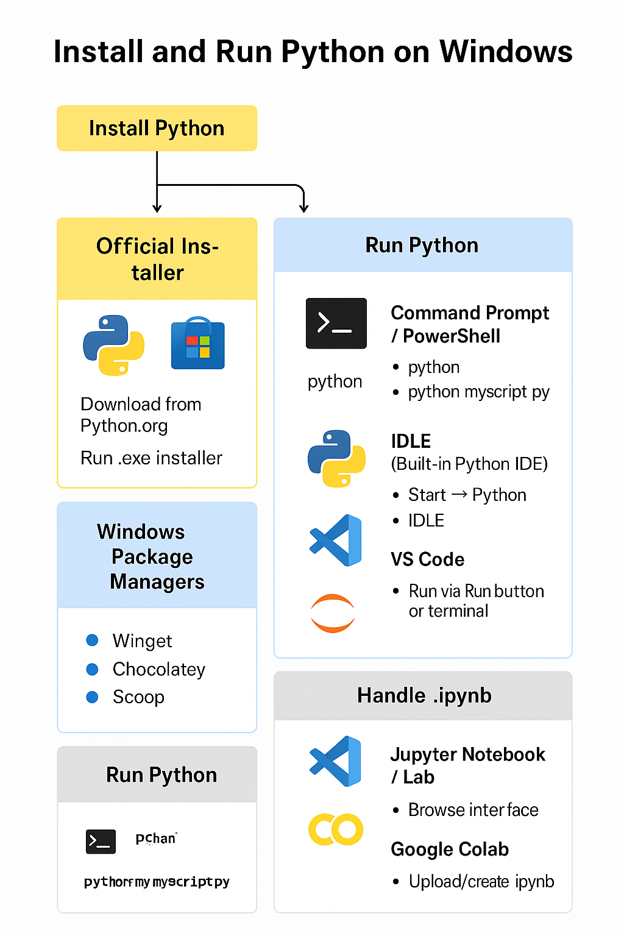

D. Using Anaconda / Miniconda
Download Anaconda or Miniconda.
Create environments:
conda create -n myenv python=3.12
conda activate myenv

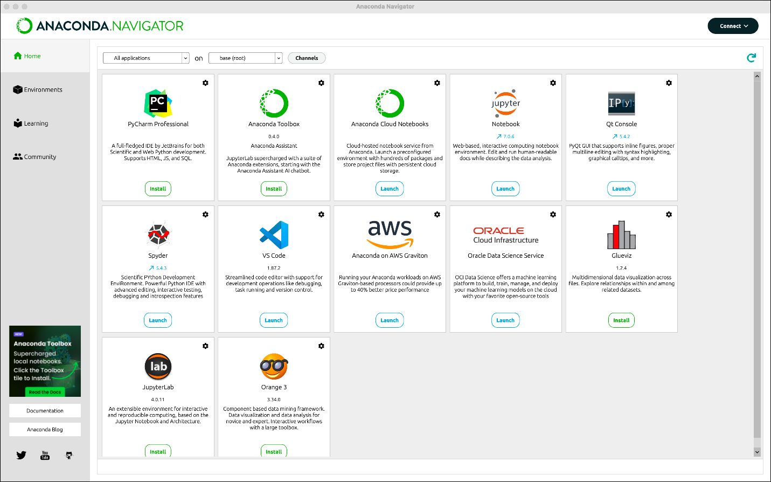

2. Running Python on Windows
https://www.geeksforgeeks.org/python/how-to-install-python-on-windows/
A. Command Prompt / PowerShell
python # interactive shell
python myscript.py # run a script

https://www.geeksforgeeks.org/python/how-to-run-an-ipynb-jupyter-notebook-from-terminal/

B. IDLE (Built-in Python IDE)
Start → Python → IDLE
Good for small scripts and testing.

https://www.youtube.com/watch?v=nO2T2IRFl50&vl=en
https://medium.com/@claudia.nikel/how-to-setup-a-jupyter-notebook-in-vs-code-w-virtual-env-kernels-install-packages-884cf643375e
C. VS Code
Install VS Code.
Install Python extension.
Open .py files:
Run via Run button or integrated terminal.
Handling .ipynb notebooks in VS Code:
Install Jupyter extension.
Open .ipynb → interactively edit & run cells.
Supports Conda/env selection for different Python versions.

https://www.dataquest.io/blog/jupyter-notebook-tutorial/

D. Jupyter Notebook / Lab
Install:
pip install notebook
# or for lab
pip install jupyterlab
Launch:
jupyter notebook
# or
jupyter lab
Opens browser interface.
Run .ipynb notebooks interactively.
Supports Markdown + Python code in cells.

E. Google Colab
Browser-based Python notebooks → no installation needed.
Open Google Colab.
Upload or create .ipynb.
Run Python interactively on Google’s cloud servers.
Can also save notebooks to Google Drive and download as .ipynb to run locally.
